YD-SL500 | 600 | 700 Silent High-Power Book Shredder
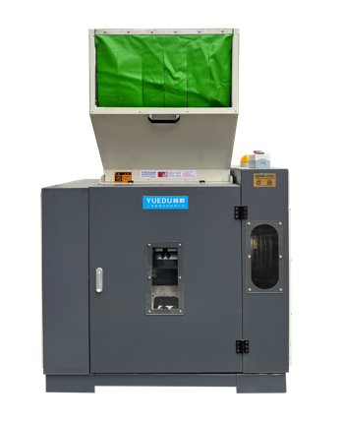 | 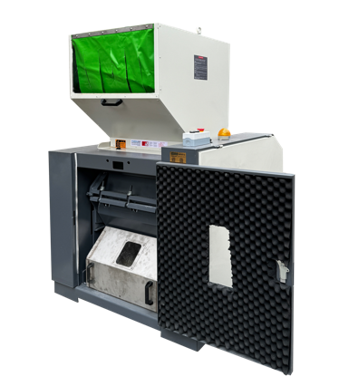 | 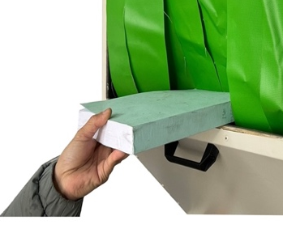 | 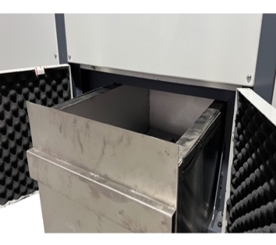
Front View | Internal View | Safe Feeding Inlet | Fully Enclosed Waste Bin
Twenty Years of Design Expertise, Proven Client Applications, and Innovative Global Technologies
As a pioneering new product, it integrates two decades of engineering excellence, extensive client application cases, and globally innovative technology. Features include but are not limited to:
● EHS-Friendly: Fully compliant with multinational companies' Environmental, Health, and Safety (EHS) standards.  ● High Efficiency, Low Energy Consumption: Saves costs while delivering exceptional performance.  ● Zero Leakage: No material leakage, no dust emissions, and no material return during operation. | ● Handles Extreme Materials: Suitable for ultra-thick and super-hard materials.  ● Adaptable to Low-Melting Plastics and Rubber: Ideal for processing heat-sensitive materials.  ● Compatible with Glass Fiber and Mineral Materials: Designed for tough, abrasive substances.

Preferred by Industry Leaders
The first choice for multinational corporations, industry leaders, and Fortune Global 500 enterprises.

Technical Specifications:
Product Model | YD-SL500 | YD-SL600 | YD-SL700
Inlet Dimensions (mm) | 400*250 | 500*260 | 600*300
Number of Sheets Shredded | 150-250 | 300-500 | 400-600
Shredding Capacity | 200-350 kg/h | 300-600 kg/h | 400-600kg/h
Motor Power | 7.5KW, 380V | 11KW, 380V | 15kw, 380V
Shredded Size(Customizable) | 8mm | 8mm | 8mm
Dimensions (mm) | 1240*1000*1563 | 1395*1160*1689 | 1550*1230*2350
Weight (kg) | 450 | 700 | 900
Pricing RMB | 67669 | 82715 | 97761
Pricing USD | 9,667 | 11,817 | 13,966
安装尺寸：
Model  产品型号 | Three-View Diagram  三视图
YD-SL700 | 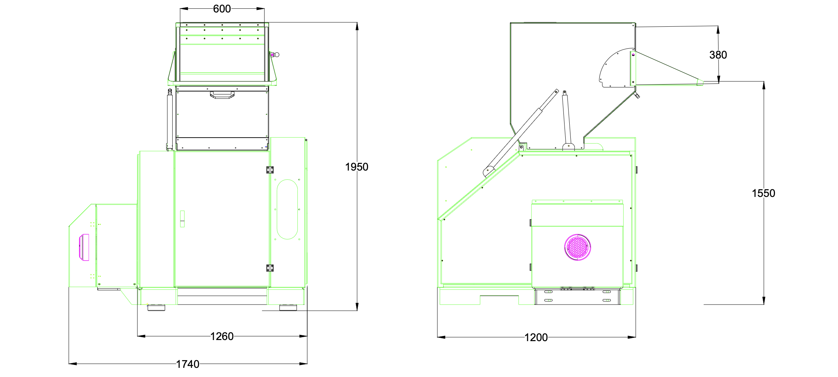
YD-SL600 | 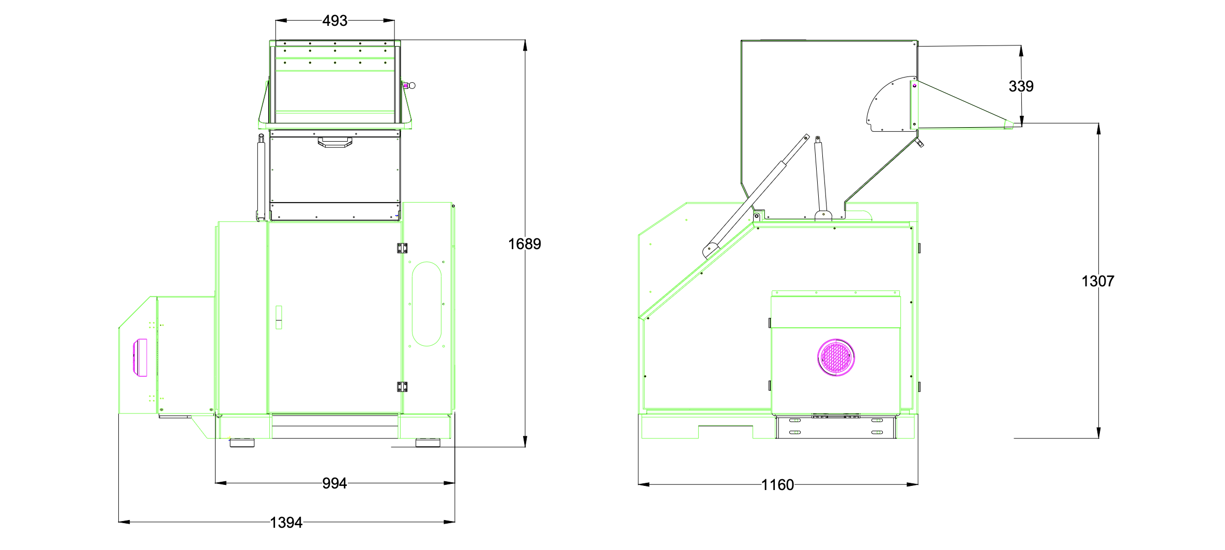
YD-SL500 | 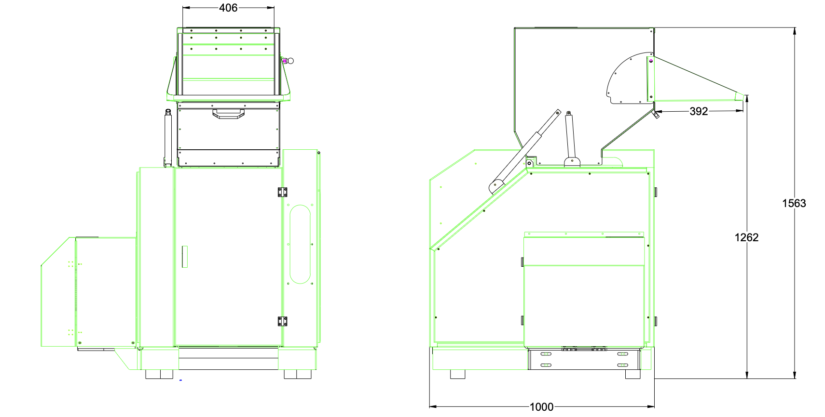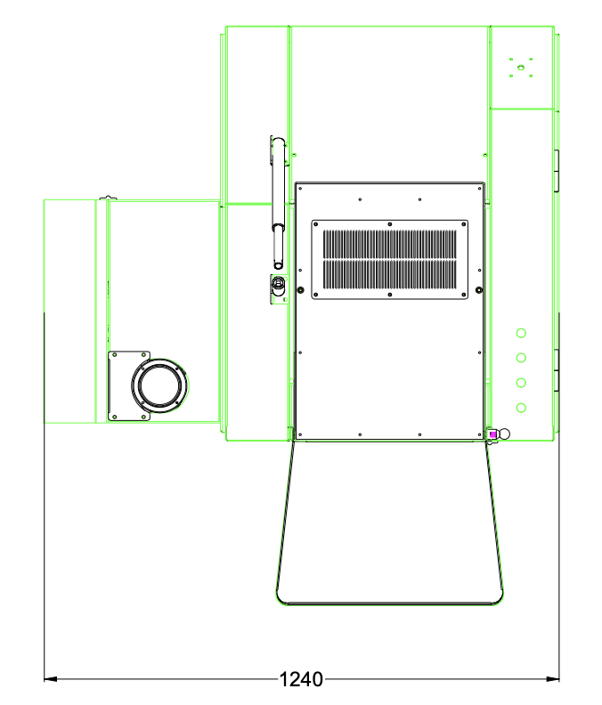



Shredding Entire Documents and Bids

Can handle 5 cm thick bids and financial documents in a single feed

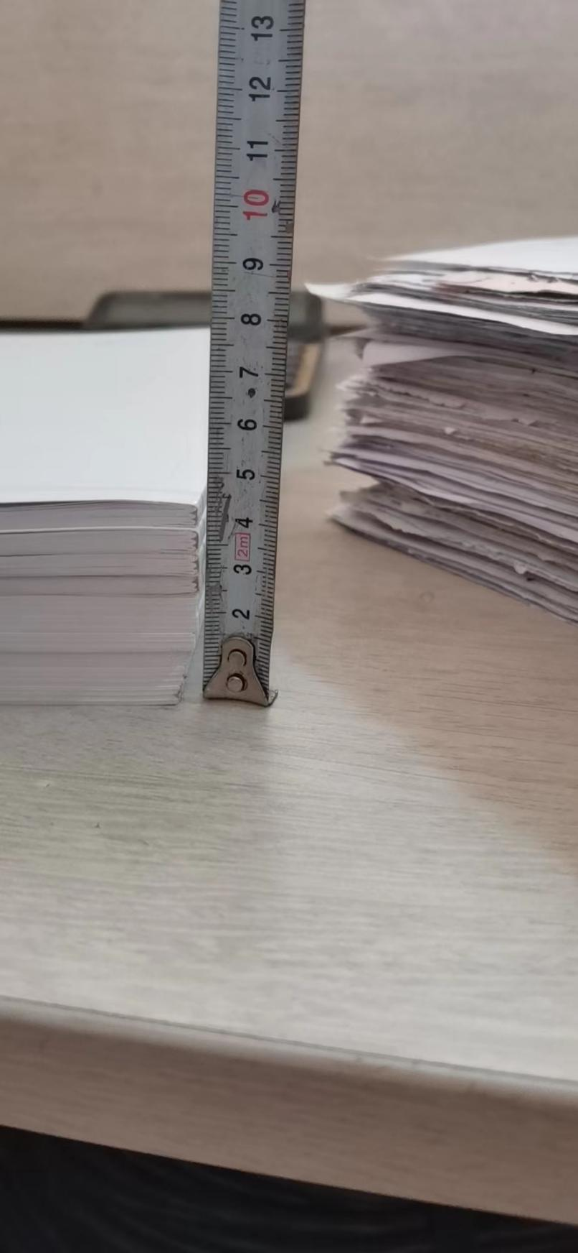 | 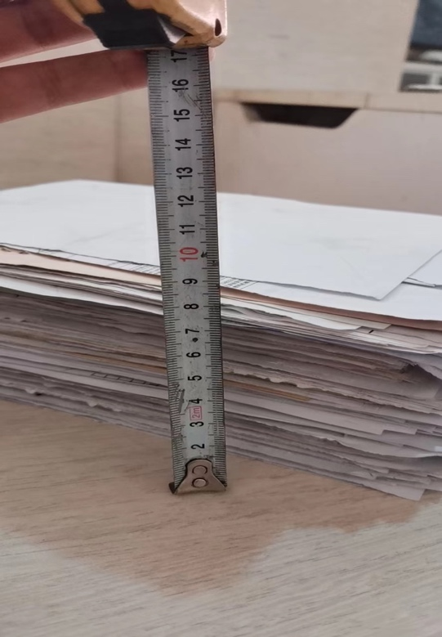

Shredding Effect (1*1mm)

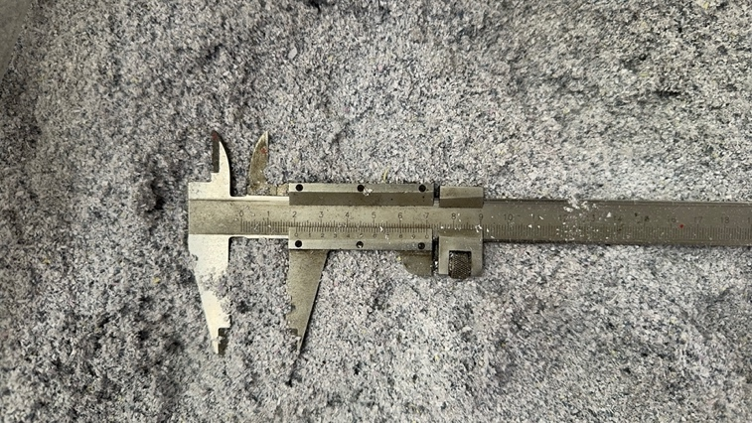 | 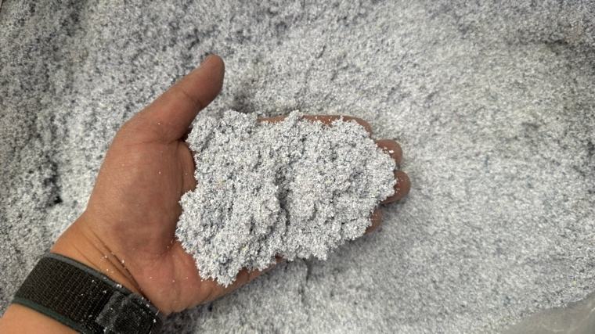

Customer Cases
Case Z
Case X
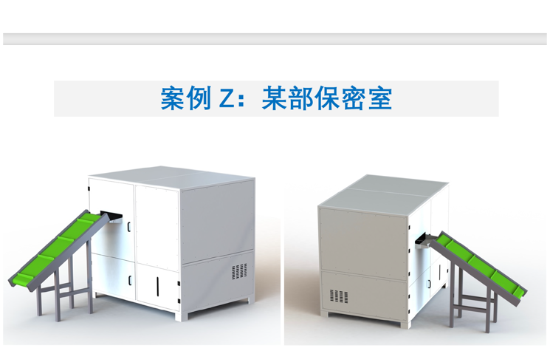 | 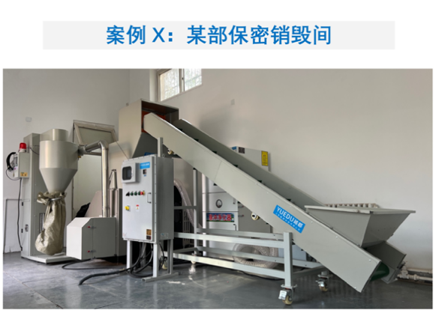

For Long-Term Operation: Feed materials evenly and wait until the materials in the shredding chamber are fully processed before adding more. For continuous feeding, ensure each batch is no more than one-third of the value specified in the table.
Shredding Capacity: The listed capacity is the maximum, applicable to hard plastics. For materials like paper, the shredding capacity decreases and depends on the output size (larger sizes process faster). For shredding paper, a 3 cm output size is recommended for faster processing.
Customizable Sizes: Available in 1mm, 3mm, and 5mm specifications. For additional options, please contact customer service.

